Matlab Interactive Fourier Based Synthesiser

Our task was to create an interactive fourier based synthesiser in matlab. This was to be achieved by loading an audio file, converting the file to a spectrogram, editing the spectrogram and converting the new image back to an audio file, playing the result

I outlined a very simple Matlab gui as a base.

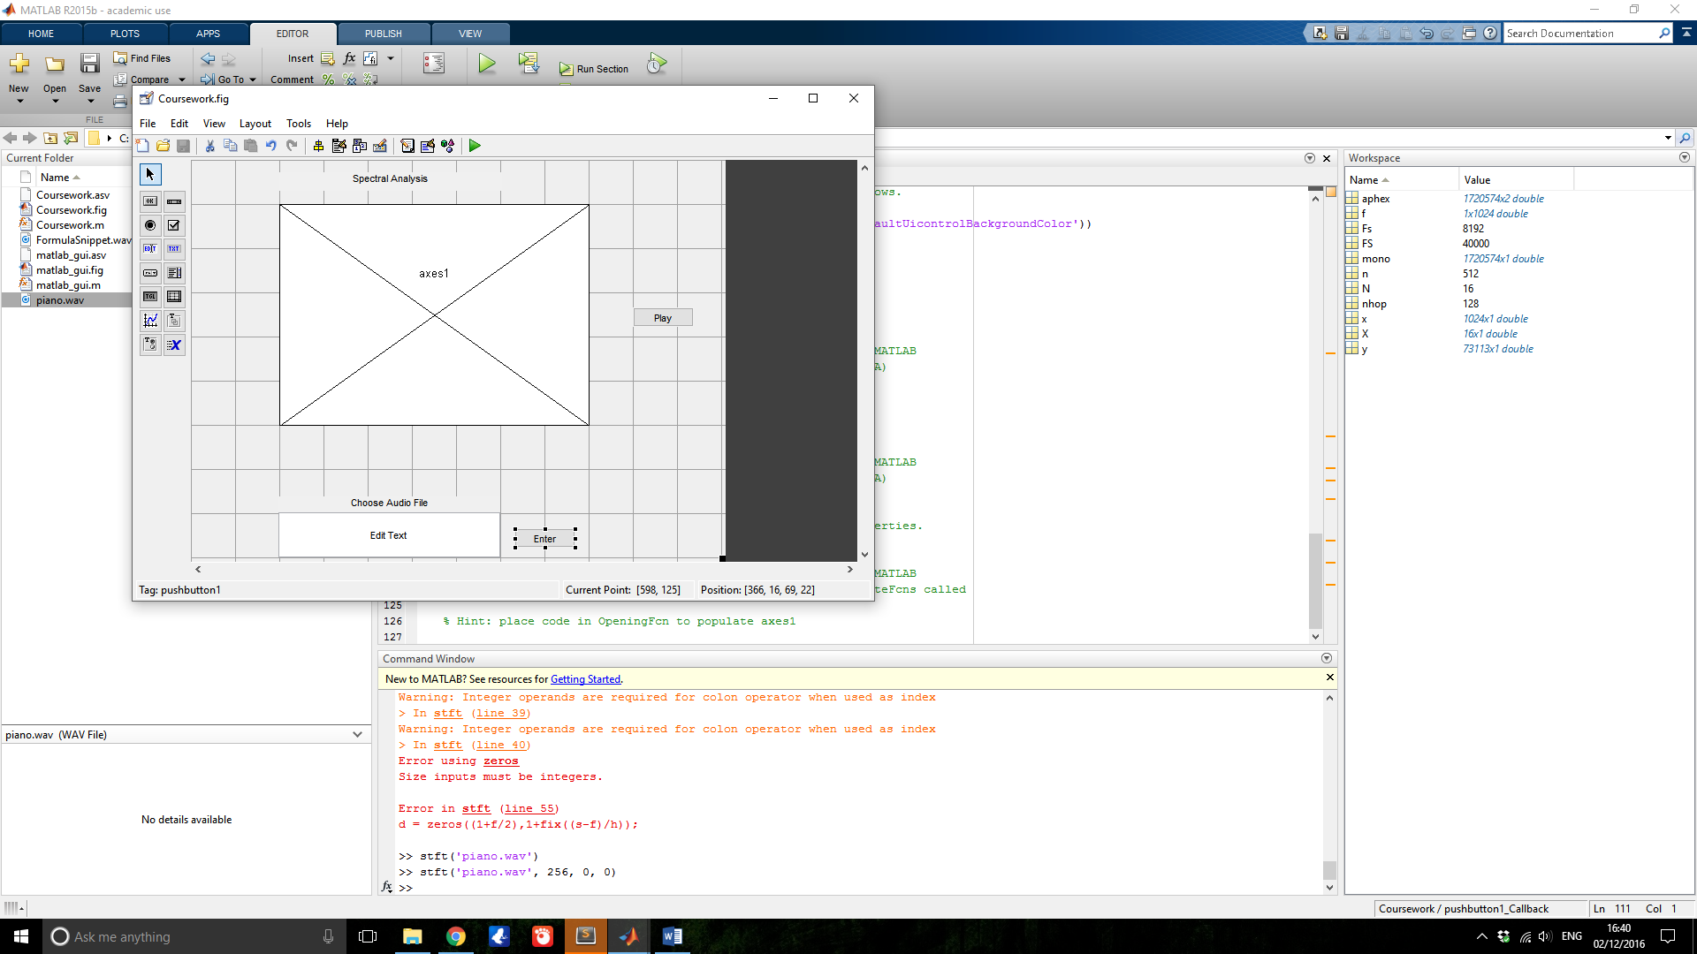

In the centre is the axes on which the spectrogram will be viewed, the button to the right is intended to play the audio file based on the current spectrogram, the text box at the bottom is for the user to specify which file they wish to load and the final button is to load the specified file.

My implementation is not fully complete and as it stands all I am able to do is produce a spectrogram from a hard coded file when the code is run.

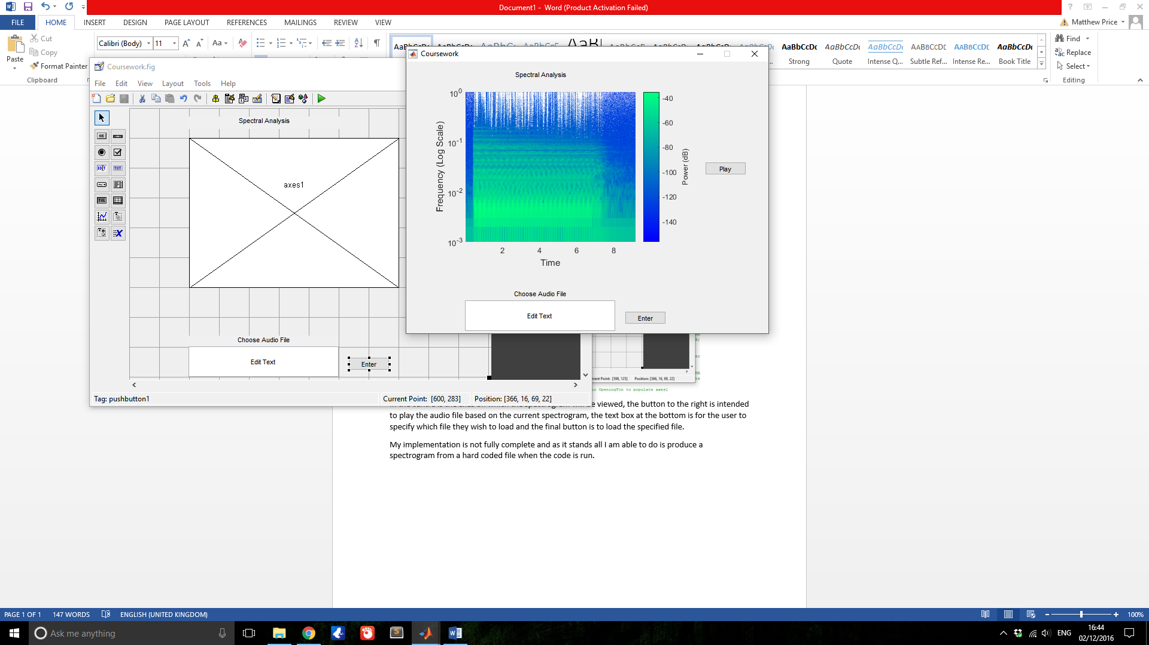

The next stage would have been to implement spectral editing. This is a feature in the iris software from which our project was inspired. Using the mouse the user would be able to alter the spectrogram to produce a different sound. In the audio file I have loaded piano.wav (one of the lab examples) you can see some white at the top of the image. This white represents noise and by doing spectral analysis can be more easily identified and removed than by other audio processing methods such as filtering.

My plan for my first extra feature was to introduce a Browse button allowing the user to browse their filed and input different audio files more easily, the edited spectra could then be saved as well. My second idea for an extra feature was to add an image to sound converter, inspired by one of our lab examples the user could select an image, the image could be converted to a spectra and then the spectra can be used to play audio.